V.L Memorial Public School
475 Vijay Nagar
Chapter - 7 - Questions - Class7th - Science
CLASS 07 - SCIENCE (CURIOSITY)

 | Section A
1 | Why are the inner walls of a solar cooker painted black?  a) To reflect more heat and cook food efficiently.  b) To emit more heat and cook food efficiently.  c) To trap more heat and cook food efficiently.  d) To absorb more heat and cook food efficiently. | [1]
2 | Why does a metal spoon feel hot when its other end is placed in a hot cup of tea?  a) The spoon radiates heat.  b) The spoon absorbs heat from the tea.  c) The spoon reflects heat.  d) Heat travels through the spoon by conduction. | [1]
3 | What process forms clouds when rising water vapour cools?  a) Water condensation process  b) Water evaporation process  c) Water transpiration process  d) Water infiltration process | [1]
4 | What happens to the air inside a partially inflated balloon when it is heated in sunlight?  a) The air disappears  b) The air contracts  c) The air freezes  d) The air expands | [1]
5 | Why does tea, when kept in a clay or porcelain cup, stay hot longer?  a) They conduct heat poorly  b) They conduct heat quickly  c) They block all heat  d) They produce heat continuously | [1]
6 | Which practice helps replenish depleted groundwater?  a) Rainwater harvesting practice  b) Reduced water infiltration  c) Excessive groundwater extraction  d) Increased concrete construction | [1]
7 | Which process includes rain, snow, and hail falling from clouds?  a) Water condensation process  b) Water evaporation process  c) Water infiltration process  d) Water precipitation process | [1]
8 | Why does heated air rise above a candle flame?  a) It becomes denser  b) It becomes cooler  c) It becomes heavier  d) It becomes lighter | [1]
9 | Why does warm air rise and cool air sink?  a) Warm air has lower pressure than cool air.  b) Warm air is denser than cool air.  c) Warm air is less dense than cool air.  d) Warm air has higher pressure than cool air. | [1]
10 | Why does woollen fabric help keep the body warm?  a) It traps air inside  b) It produces heat inside  c) It absorbs sunlight directly  d) It traps water inside | [1]
11 | A wooden spoon is dipped in a cup of ice cream. Its other end:  a) becomes cold by the process of conduction.  b) does not become cold.  c) becomes cold by the process of radiation.  d) becomes cold by the process of convection. | [1]
12 | Which material allows water to seep through most easily?  a) Aquifer  b) Sand  c) Clay  d) Gravel | [1]
13 | Which of the following is an example of convection?  a) Ice melting in a drink.  b) Air rising from a heater.  c) A metal spoon getting hot in a cup of tea.  d) Sunlight warming the Earth. | [1]
14 | Which material allows water to seep through most slowly?  a) Sand  b) Aquifer  c) Clay  d) Gravel | [1]
15 | Which type of materials allows heat to pass through them easily?  a) Good conductors  b) Thermal insulators  c) Poor conductors  d) Heat reflectors | [1]
16 | Why does a black surface feel hotter than a white surface under the sun?  a) Black surfaces trap more heat.  b) Black surfaces emit more heat.  c) Black surfaces absorb more heat.  d) Black surfaces reflect more heat. | [1]
17 | Why are dark - coloured clothes comfortable during winters?  a) They produce more heat  b) They block more heat  c) They absorb more heat  d) They reflect more heat | [1]
18 | In which state of matter does convection primarily occur?  a) Solids  b) Liquids and gases  c) All of these  d) Plasma | [1]
19 | Why does the direction of wind reverse between daytime and nighttime near the seashore?  a) Water remains equally cool  b) Land heats and cools faster  c) Land remains equally warm  d) Water heats and cools faster | [1]
20 | Why do we wear light - colored clothes in summer?  a) Light - colored clothes reflect more heat.  b) Light - colored clothes emit more heat.  c) Light - colored clothes absorb more heat.  d) Light - colored clothes trap more heat. | [1]
21 | Assertion (A): Water is a poor conductor of heat compared to metals.  Reason (R): Water molecules are loosely packed, reducing heat transfer by conduction.  a) A is true but R is false.  b) Both A and R are true but R is not the correct explanation of A.  c) Both A and R are true and R is the correct explanation of A.  d) A is false but R is true. | [1]
22 | Assertion (A): Radiation is a method of transfer of heat.  Reason (R): The process of heat transfer that does not require any medium is called convection.  a) Both A and R are true and R is the correct explanation of A.  b) Both A and R are true but R is not the correct explanation of A.  c) A is true but R is false.  d) A is false but R is true. | [1]
23 | Assertion (A): Dark - colored clothes absorb more heat than light - colored clothes.  Reason (R): Dark surfaces are good absorbers of heat radiation.  a) Both A and R are true and R is the correct explanation of A.  b) Both A and R are true but R is not the correct explanation of A.  c) A is true but R is false.  d) A is false but R is true. | [1]
24 | Assertion (A): Sea breeze refers to the movement of cold air from sea towards sea during time.  Reason (R): Land breeze refers to the movement of cold air from land towards sea during night time.  a) Both A and R are true and R is the correct explanation of A.  b) Both A and R are true but R is not the correct explanation of A.  c) A is true but R is false.  d) A is false but R is true. | [1]
25 | Assertion (A): Land breezes occur at night.  Reason (R): At night, land cools faster than water, creating a pressure difference.  a) Both A and R are true and R is the correct explanation of A.  b) Both A and R are true but R is not the correct explanation of A.  c) A is true but R is false.  d) A is false but R is true. | [1]
26 | Assertion (A): Evaporation is a process where water changes into vapour and rises into the atmosphere.  Reason (R): Evaporation requires heat energy from the Sun or other sources.  a) Both A and R are true and R is the correct explanation of A.  b) Both A and R are true but R is not the correct explanation of A.  c) A is true but R is false.  d) A is false but R is true. | [1]
27 | Assertion (A): Conduction is the transfer of heat through a material without the movement of its particles itself.  Reason (R): In conduction, heat moves from the colder part to the hotter part of the material.  a) Both A and R are true and R is the correct explanation of A.  b) Both A and R are true but R is not the correct explanation of A.  c) A is true but R is false.  d) A is false but R is true. | [1]
28 | What is the movement of cooler air from land towards the sea at night called? | [1]
29 | Why does land heat up faster than water during the day? | [1]
30 | What is the process by which heat is transferred through direct contact of particles in a material? | [1]
31 | Describe the change observed in a partially inflated balloon when the air inside it is heated by the Sun. | [1]
32 | Briefly mention one application of kink in the clinical thermometer. | [1]
33 | Why do we wear light - colored clothes in summer? | [1]
34 | Describe the three states in which water exists in nature. | [1]
 | Section B
35 | Match the following: | [2]
  Column A | Column B
  (a) Hot air balloon | (i) Warm air rises and cooler air takes its place
  (b) Boiling water | (ii) Convection occurs in gases
  (c) Air movement | (iii) Convection currents form
  (d) Liquids and gases | (iv) Water heats and circulates
36 | Match the following: | [2]
  Column A | Column B
  (a) Sunlight | (i) Absorbs more heat than shiny surfaces
  (b) Black surface | (ii) Heat transfer without a medium
  (c) Radiation | (iii) Travels through vacuum
  (d) Dull and rough surface | (iv) Source of radiant heat
37 | Why do birds puff up their feathers in winter? | [2]
38 | Explain how water seeps through the surface of the Earth and gets stored as groundwater. | [2]
39 | Describe how an ice stupa forms and supplies water in Ladakh. | [2]
40 | Explain why tea or coffee stays hot longer in clay or porcelain cups. | [2]
41 | If you place ice wrapped in wool and another in metal, which will melt faster? Why? | [2]
42 | Explain why a black car gets hotter than a white car in sunlight. | [2]
43 | How does a vacuum flask prevent heat loss? | [2]
 | Section C
44 | How does a greenhouse maintain warmth for plants in winter? | [3]
45 | Why does a metal spoon feel colder than a wooden spoon at room temperature? | [3]
46 | Explain why coastal areas have moderate climates compared to inland regions. | [3]
47 | Why are two thin blankets warmer than one thick blanket? | [3]
48 | Evaluate why light - coloured clothes are preferred in summers while dark - coloured clothes are preferred in winters. | [3]
49 | How does a thermos flask prevent heat transfer by conduction, convection, and radiation? | [3]
50 | Explain why a copper pan heats up faster than a steel pan when placed on the same stove. | [3]
 | Section D
51 | Read the following text carefully and answer the questions that follow:  We have observed that water seeps fastest through gravel, slower through sand, and slowest through clay. The spaces between gravel particles are wider when compared to those in sand and clay. Hence, water can seep through the gravel more easily. In this way, water seeps beneath the surface of the Earth. This process of surface water seeping through soil and rocks is called infiltration. Water can infiltrate more readily if the spaces between soil and rock particles are wider, open, and interconnected. The water that seeps through gets stored in the pore spaces of sediments and the openings in rocks beneath the surface as groundwater. The underground layers of sediments and rocks that store water in pore spaces are called aquifers. This is the water we extract by digging wells or drilling bore wells into aquifers. This water may be a few metres to hundreds of metres below the ground, depending on the location. However, groundwater is not unlimited. The growing water requirements of an increasing population have led to excessive groundwater extraction. Additionally, decreased vegetation cover and increased concrete surfaces in urban areas have limited water infiltration. Questions:  - Why does water seep faster through gravel compared to sand and clay? (1)  - What is the process of infiltration, and how does it contribute to groundwater storage? (1)  - What are aquifers, and how do we extract water from them? (2)  - OR  - How does the increasing urbanization and reduced vegetation affect groundwater infiltration? (2) | [4]
52 | Read the following text carefully and answer the questions that follow:  On a chilly evening in Gangtok, Pema and her brother Palden sit by the fireplace. Palden recalls his recent trip to Kerala, where he experienced warmer, more humid weather. Curious about this difference, they ask their grandfather, who explains that Kerala is closer to the equator and has a long coastline, leading to higher temperatures. Their conversation soon turns to heat and its transfer, especially while observing their grandmother cook thukpa in a metal utensil. This sparks a discussion on conduction, and how metals like aluminium and iron transfer heat effectively, as shown in classroom activities with falling pins. They also note that poor conductors like wood and glass don’t transfer heat easily, which is why they’re used in cups or for insulation. Later, as they observe rising smoke from the fire and perform experiments with hot air and water, they learn about convection - heat transfer due to the movement of heated particles. Palden relates this to his beachside observations in Kerala, where land heats and cools faster than water, causing sea and land breezes. Their curiosity leads to a deeper understanding of how heat behaves in solids, liquids, and gases. Questions:  - Why are cooking utensils generally made of metals and not materials like wood or plastic? (1)  - Why did the pin closest to the flame fall first during the heat conduction experiment in the classroom? (1)  - Describe how the movement of coloured water during the convection experiment explains heat transfer in liquids. How does this relate to heating in everyday cooking? (2)  - OR  - Palden noticed a sea breeze during his trip to Kerala. Using the concept of differential heating of land and water, explain how sea and land breezes occur and why they are common in coastal areas. (2) | [4]
53 | Read the following text carefully and answer the questions that follow:  Water exists in three states in nature, as a liquid, it fills the oceans, rivers, and lakes on the Earth. As a solid, it forms snow, ice sheets, and glaciers in the mountains and the polar regions. As a gas, it exists in the form of water vapour in the Earth’s atmosphere. During summers, some of the snow and ice gets converted to water due to the Sun’s radiation and flows down as rivers, and ultimately into the oceans. The melted ice is replenished by fresh snow during winters. Water in the oceans, rivers, and lakes gets heated due to the Sun, and as a result, it evaporates as water vapour. Water also evaporates from trees and plants through transpiration. When water vapour rises up, it cools down and condenses to form clouds. Clouds bring rain, snow, and hail. This process is called precipitation. The continuous movement of water - upward as water vapour and downward through precipitation, passing through soil, rocks, and plants, and finally returning to water bodies, is called water cycle.  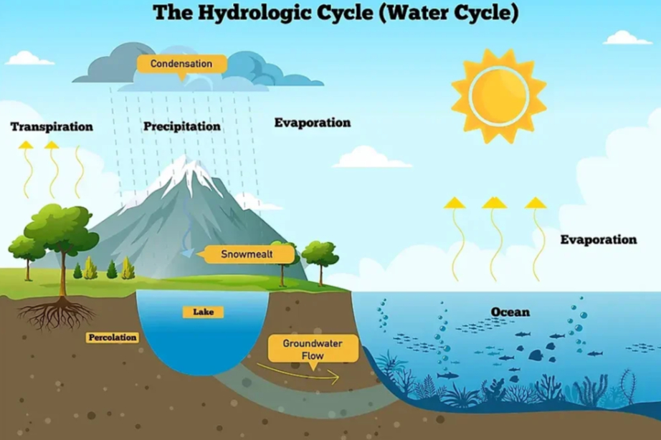  Thus, the water cycle helps in redistributing and replenishing water in rivers, lakes, and oceans. It also serves to conserve the total amount of water on the Earth. Rainwater that falls on the surface of the Earth, flows into ponds, lakes, rivers, and oceans or seeps into the ground. Questions:  - How does water change its state in nature, and where does it exist in each state? (1)  - What role does the Sun play in the water cycle? (1)  - Explain how water vapour forms clouds in the atmosphere. (2)  - OR  - What is the water cycle, and how does it help in replenishing water on Earth? (2) | [4]
 | Section E
54 | Explain the formation of land and sea breezes with diagrams. How do they affect coastal climates? | [5]
55 | Analyze how the bukhari demonstrates all three processes of heat transfer. | [5]
56 | What is convection and how does it work in liquids and gases? | [5]
57 | What is radiation? How does it help in heat transfer from the Sun to the Earth? | [5]
58 | Why are houses in hot regions often painted white and have thick walls? Explain scientifically. | [5]
59 | Compare conduction, convection, and radiation with examples from daily life. | [5]
 | Section F
60 | State whether the given statement is True or False:  - Water at a higher temperature feels hotter.  - Metals are poor conductors of heat.  - Areas with clay materials allow more seepage of water than those with sandy materials.  - Water and air are good conductors of heat.  - Land heats up and cools down faster than water, leading to sea and land breezes.  - Metals are good conductors of heat.  - Evaporation and condensation are key processes in the water cycle.  - The Sun does not play any role in the water cycle. | [8]
61 | Fill in the blanks:  - The hot bodies radiate________.  - A black surface absorbs more ________ than a white or shiny surface.  - Sea breezes are caused by the process of ________.  - Metal is a ________ conductor of heat.  - During convection, hot air becomes ________ and rises up while cooler air sinks down.  - The process of heat transfer in fluids is called ________.  - Dark - colored clothes absorb more heat than ________ - colored clothes.  - The process of heat transfer in solids is known as ________. | [8]

